**LAB Report #3: Development of a Single-Axis Force Sensor using Strain Gauges**

Reporter: MINGSHAN HE (2022-24052, hemingshan@snu.ac.kr)

Instructor: Yong-Lae Park

Lab Assistant: Tae Hwa Hong, Sung Jin Kim

**Results**

1. Provide pictures of your bracket and experimental setup.

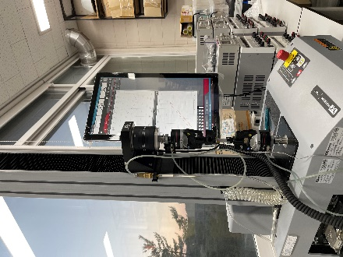

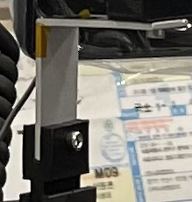

1. Plot a Graph for the parameters in the first configuration.

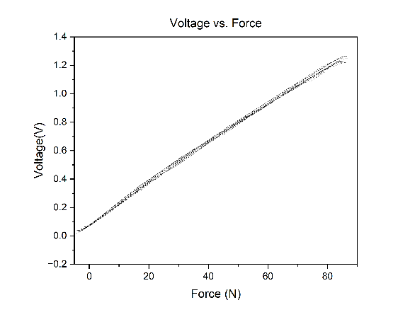

1. Provide your calibration matrix $C$.

$$C=0.01625$$

**Discussion**

1. Describe the relationship in the graph. Are they linear? Why, or why not?

The more force applied on the sensor, the more voltage can be detected. And the relationship between force and voltage is linear. Because the function of them can be described by a linear function.

1. Discuss the sensitivity of the signal.

In this lab, I can know the sensitivity by the data collected by lab setup. When the change of force exactly 0.1N happened, the voltage was changed with in 0.001625V, which is concluded by the data and it is the calibration matrix. I think the sensitivity is determined by the circuit and VCC applied in the circuit. If the circuit has the larger amplify coefficient and range, the sensor could detect more sensitive and larger force in the range of sensor.

1. What kind of effect would misalignment of the strain gauge cause? Is this a concern in your system?

In the reference, it has introduced that when we estimate the weight of the movable parts, it may happen the possible load errors including the vertical misalignment and rotation angle error. And it also could happen the practical sensor orientation control. Both of them are avoided. The sensor vertical misalignment is a concern in my system.

1. Discuss the advantages and limitations of using this type of strain gauge setup force sensing.

At first, the sensor can measure a wide range of force which is determined the amplified circuit and its properties. And it can provide multiple force information along the different directions. Mostly, it can provide the force directly with the means of measurement and the system is in low power, low noise, high sensitivity and insensitivity to temperature variation and cost effective.

1. Are the force outputs coupled? Why or why not?

No.

The force outputs are not coupled, because the outputs could be decoupled in two voltages (Voltage A and Voltage B).

1. Find your calibration matrix $C$ using pseudo-inverse.

$$S_{1}^{-1}={\left[S_{11} S_{12}\right]}^{-1}=\left[\begin{matrix}-2.2574 & 3.8269 \\ \begin{matrix}1.6416 \\ \begin{matrix}-0.4209 \\ \begin{matrix}4.4604 \\ \begin{matrix}1.3781 \\ \begin{matrix}1.3178 \\ \begin{matrix}-1.4121 \\ \begin{matrix}-3.7070 \\ \begin{matrix}1.7592 \\ -0.8131\end{matrix}\end{matrix}\end{matrix}\end{matrix}\end{matrix}\end{matrix}\end{matrix}\end{matrix} & \begin{matrix}-2.7589 \\ \begin{matrix}0.7376 \\ \begin{matrix}-7.5086 \\ \begin{matrix}-2.2873 \\ \begin{matrix}-2.1759 \\ \begin{matrix}2.4490 \\ \begin{matrix}6.3402 \\ \begin{matrix}-2.8970 \\ 1.4619\end{matrix}\end{matrix}\end{matrix}\end{matrix}\end{matrix}\end{matrix}\end{matrix}\end{matrix}\end{matrix}\right]; S_{2}^{-1}={\left[S_{21} S_{22}\right]}^{-1}=\left[\begin{matrix}5.0115 & -0.0538118 \\ \begin{matrix}10.0645 \\ \begin{matrix}-0.931986 \\ \begin{matrix}-5.46728 \\ \begin{matrix}-0.331477 \\ \begin{matrix}8.09705 \\ \begin{matrix}-5.86082 \\ \begin{matrix}6.19179 \\ \begin{matrix}-1.2204 \\ -5.30173\end{matrix}\end{matrix}\end{matrix}\end{matrix}\end{matrix}\end{matrix}\end{matrix}\end{matrix} & \begin{matrix}-0.10843 \\ \begin{matrix}0.0400146 \\ \begin{matrix}0.106428 \\ \begin{matrix}0.0501972 \\ \begin{matrix}-0.0482585 \\ \begin{matrix}0.135961 \\ \begin{matrix}-0.01117 \\ \begin{matrix}0.0894055 \\ 0.14695\end{matrix}\end{matrix}\end{matrix}\end{matrix}\end{matrix}\end{matrix}\end{matrix}\end{matrix}\end{matrix}\right] \\ {F_{1}S}_{1}^{-1}=\left[\begin{matrix}0.5629 & 2.4060\end{matrix}\right];F_{2}S_{2}^{-1}=[\begin{matrix}-8.0084 & 3.3730\end{matrix}]$$

$$C=\left[{F_{1}S}_{1}^{-1},{F_{2}S}_{2}^{-1}\right]=[\begin{matrix}0.5629 & 2.4060 \\ -8.0084 & 3.3730\end{matrix}]$$

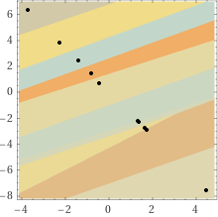 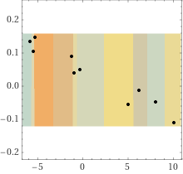

1. Please find the determinant of your $C$. What does the value of the determinant tell you?

$$Δ\left(C\right)=0.5629*3.3730-2.4060*-8.0084=1.8986617+16.8656904=18.7643521$$

The determinant of matrix is larger than zero, which means the matrix is full rank. And the columns and rows are independent variable, thus the two voltages are decoupled and independent.